Worksheet 3.2

Isolation and new species
Student: Class:
1. The following cartoon and statements summarise how isolation can lead to the formation of new species.
(a) Place the statements in the correct order in the flow chart using the letters A–G.
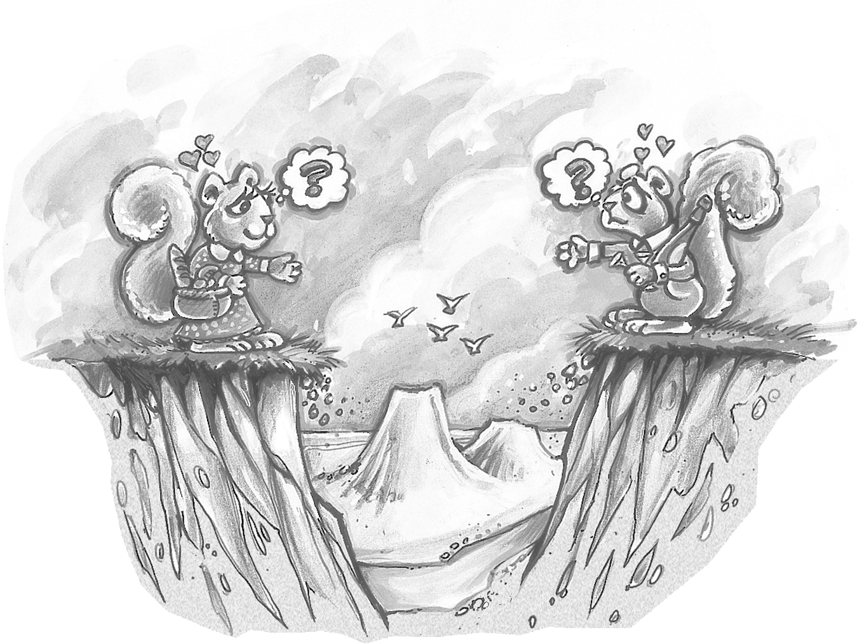

A | Survivors reproduce and pass on favourable genes and features to offspring. | B | The environment changes. Because of selection, some characteristics are favoured over others. Those best suited to the environment survive. | C | The frequency at which the genes for the new characteristics appear increases. | D | The breeding population becomes isolated.

 | E | Different characteristics arise through random genetic drift, mutation and environmental pressures. | F | The isolated population is now quite different, producing a new species. | G | Variation of characteristics is present in a population.
(b) Explain the meaning of the cartoon in relation to the formation of new species.

Worksheet 3.2

Page 2

2. The Australian emu, the African ostrich and the kiwi in New Zealand are believed to have evolved from a common ancestor.
(a) Explain why it is possible for flightless birds in Australia, New Zealand and Africa to have a common ancestor even though these landmasses are now separated by oceans.

(b) The emu and the kiwi are quite different birds. Explain how one species of flightless birds can evolve into a number of different species over time.

